Listen to this speech by Martin Luther King
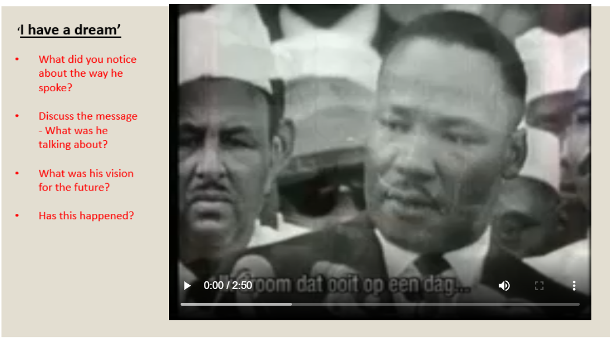
https://www.youtube.com/watch?v=vP4iY1TtS3s


